The Residents: Aden D’occhio, Alessandro DiCesare, and Fatima Chowdhury

CS460W Software Development – Professor Ingrid Russell

C.A.R.E.S System Installation Document for Users

C.A.R.E.S. System (Russell-Stover Memorial Hospital)

Because We Care

**About C.A.R.E.S.**

The Connecticut Advanced Russell Emergency Service (C.A.R.E.S) System is a software platform designed to streamline emergency room operations within the hospital. It enables healthcare providers to swiftly and securely access vital patient information in real-time, thereby enhancing the quality of medical care delivered. The system operates on both desktop and laptop computers and necessitates continuous access of the database by an authorized hospital personnel to ensure seamless functionality. Access to the software is granted to ER Front Desk Staff, Doctors, Nurses, and Billing Staff, with each user being assigned specific privileges based on their role, in compliance with HIPAA regulations to safeguard patient confidentiality. This document provides comprehensive instructions for the installation and utilization of the C.A.R.E.S System. Please review all outlined steps to effectively deploy the C.A.R.E.S System on your computer.

**How to install and run C.A.R.E.S on your computer**

**Step 1:**

Save the JAR file named C.A.R.E.S.jar to your computer. Locate the downloaded file in your Downloads folder and execute it. This action will launch the login interface, depicted in the screenshot provided below.

**Step 2:**

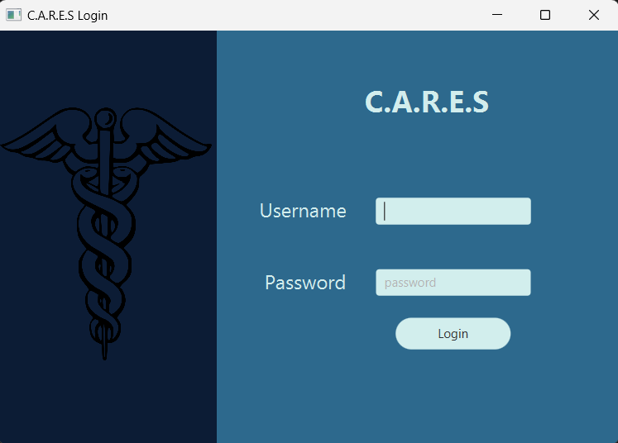Use your individual username and password to access the system. The README file bundled with the software contains the default login credentials assigned to each authorized user.

Note: Username and Password are case sensitive and must not include unnecessary spaces.

**Step 3:**

If you are logging in as the front-desk staff, you will have access to the following functions, as illustrated in the screenshot:

* Enter patient information

Note: The entered information must adhere to the specified format within the text box; otherwise, an error message will appear.

* Check-In patient

To Check-in a patient, fill out all the fields with the specified information within the textbox and click on the “Check-In” button.

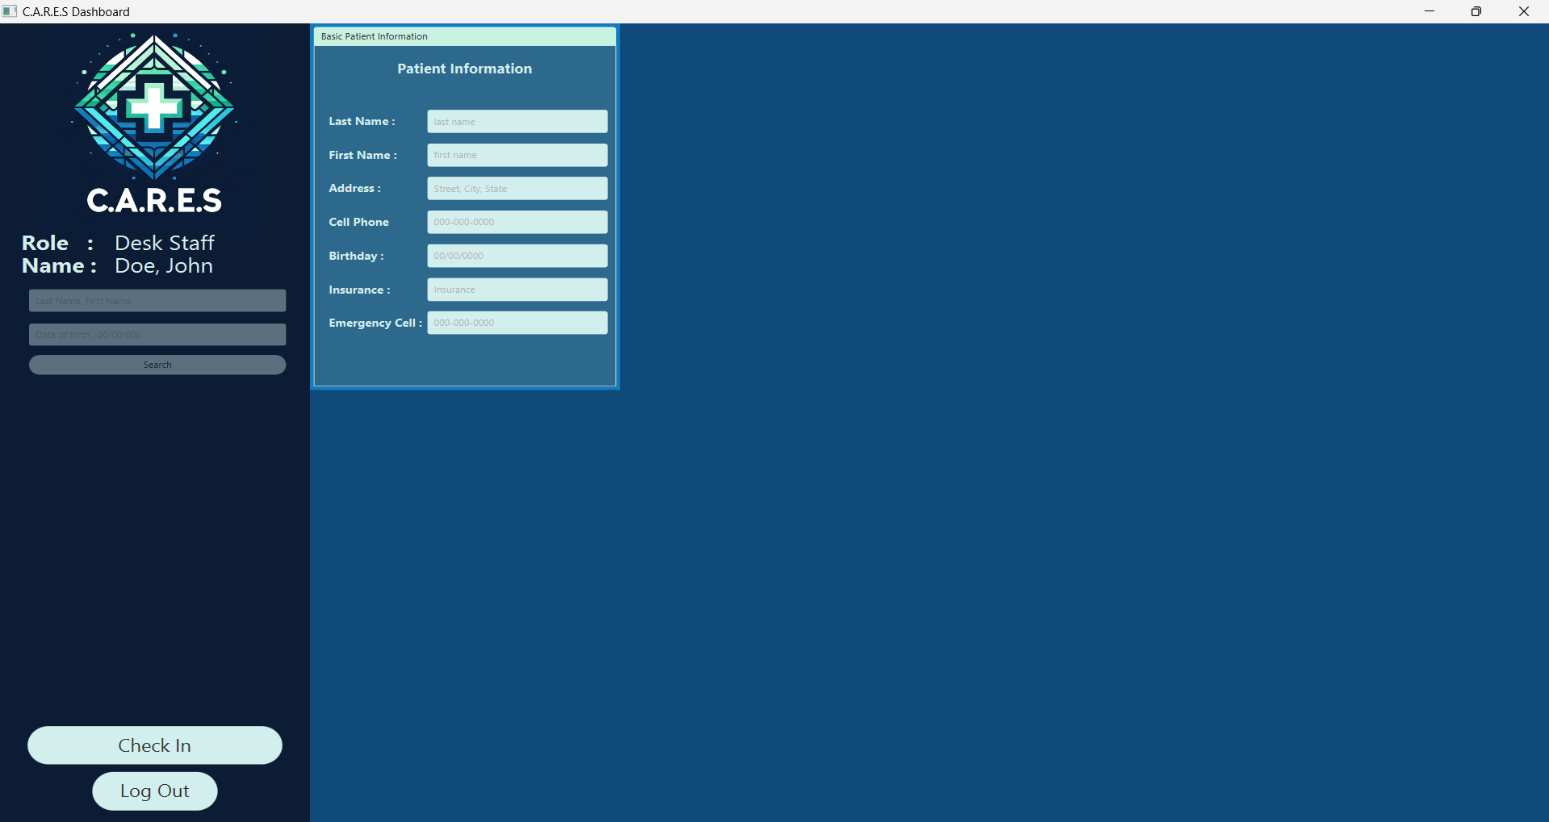

If you are logging in as a Doctor, the system will grand you access to the following features, as shown in the screenshot:

* Search for a patient using the patient’s last name followed by a comma, a space, and then their first name, and their date of birth in the format mm/dd/yyyy, then click on the “Search” button.

Please refer to the screenshot below for an example.

* Enter/Edit Basic Patient Information
* Enter/Edit Medical Information

Note: Please ensure that you enter the information in the exact format specified within the text field. To edit the information, you can delete the existing information and enter the new information. The updates will be automatically saved into the system.

* Admit a Patient

To admit a patient, you must first search the patient using their last name, comma, first name, and DOB, and then click on the “Search” button. The system will pull up all the available information for the specific patient. You can now enter any additional information and click on the “Admit Patient” button.

Note: The patient’s admission status appears under the “Medical Information” section,

* Run Lab tests

To run labs, select the specific labs that need to be run, and then click on the “Run Labs” button. The results of the selected labs will show up on the “Lab Results” section as either “Normal” or “Abnormal”.

* Access Lab Results

To view the results of previously run lab tests, you must first search for the patient as described above. The results of the lab tests ordered by a doctor will be accessible in real-time after clicking the 'Run Labs' button.

* Diagnose

To make a diagnosis, you must select the relevant condition. The changes will be saved automatically as you make the updates.

* Prescribe medications

Only after selecting the relevant conditions, you may also select prescriptions associated with that condition. The changes will be saved automatically.

* Write Discharge Instructions on the text box on the right side of the screen

Use the text box on the right side of the screen under “Discharge” to write instructions the patient must follow upon and following their discharge from the hospital.

* ONLY complete Discharge after a nurse has previously started the discharge of a patient

To complete the discharge of a patient, select the “Discharge” button.

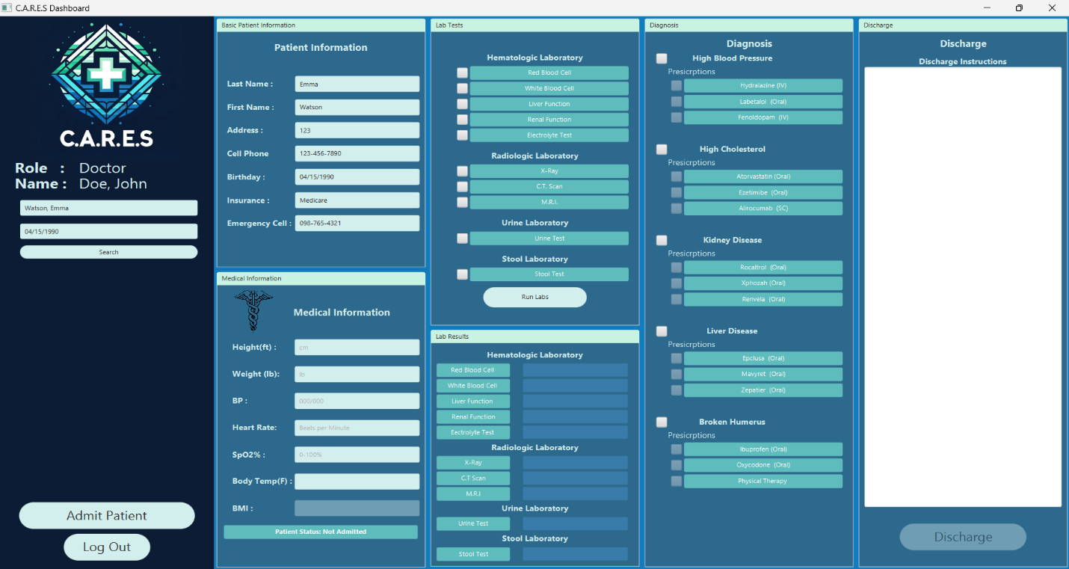

If you are logging in as a Nurse, you will have access to the following, as shown in the screenshot below:

* Search Patient
* Enter/Edit Patient and Medical information
* Run Labs
* Access Lab Results
* Start Discharge
* Include Discharge Instructions in the text box on the right side of the screen.

To use all the functions listed above, follow the same procedures as specified for the Doctor in this document.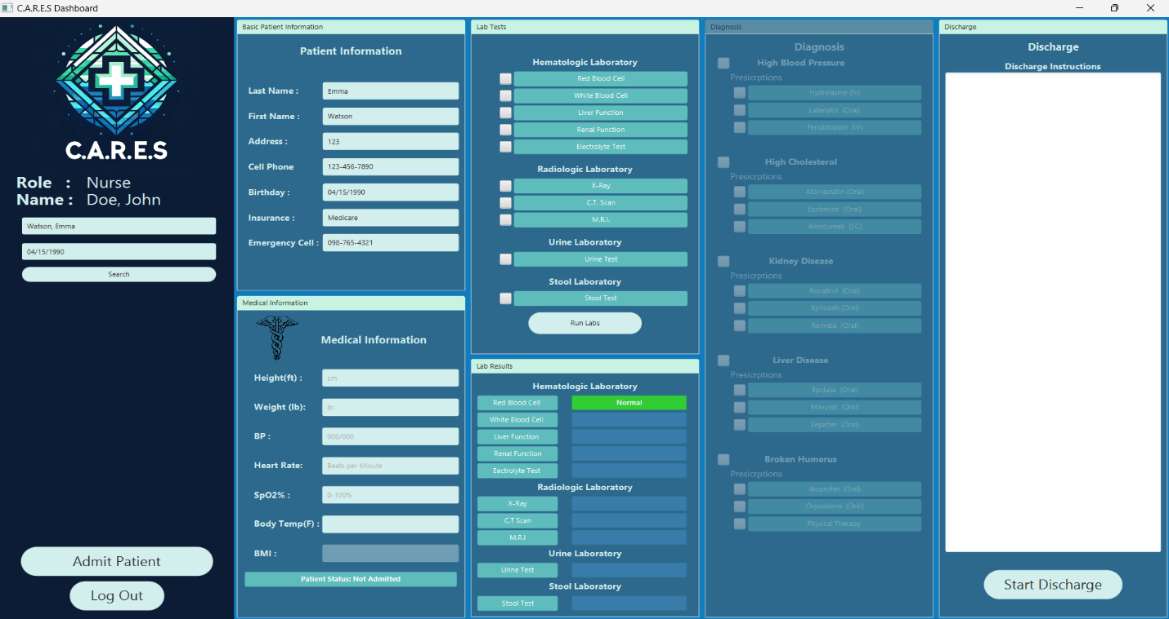

If you are logging in as a Billing Staff, you will be able to access the patient’s bill by searching for a specific patient using their last name, first name, and DOB, and the C.A.R.E.S System will automatically generate the bill based on the services received by the patient.

